Hands-on Example: Template Testing & Template Libraries
1. Template Testing
Scenario: A company wants to generate monthly sales reports using a reusable prompt template.
Step 1: Create a prompt template
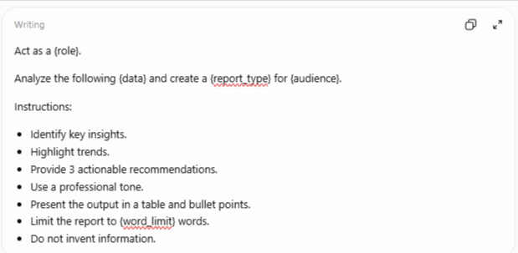

Step 2: Test the template with different inputs
Test | Role | Data | Report Type | Audience
Test 1 | Business Analyst | Monthly sales | Sales Summary | Management
Test 2 | HR Analyst | Employee attendance | Attendance Report | HR Manager
Test 3 | Financial Analyst | Revenue and expenses | Financial Report | Finance Team

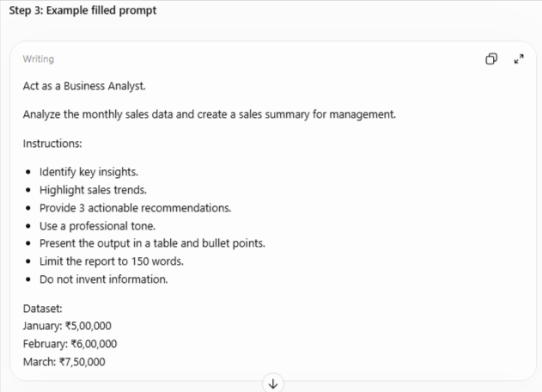

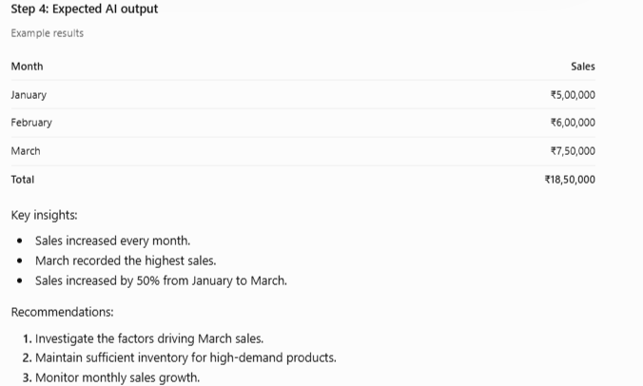

Step 5: Template validation
- Correct calculations
- Relevant insights
- Professional tone
- Required table and recommendations
- Output follows constraints
Learning: Test the same template with different datasets and audiences to check whether it produces consistent, accurate, and useful results.

2. Template Libraries
Scenario: An AI training company wants to maintain reusable prompts for trainers, analysts, and managers.
Example: Prompt Template Library
Template ID | Category | Template Name | Purpose
PT001 | Business | Sales Analysis | Analyze sales and trends
PT002 | Email | Professional Email | Generate business emails
PT003 | Training | Training Plan | Create session plans
PT004 | Reporting | Weekly Report | Generate management reports
PT005 | Data Analysis | Dataset Analysis | Analyze structured data
PT006 | HR | Leave Request | Draft leave emails
PT007 | Finance | Financial Summary | Summarize financial data
PT008 | Content | Social Media Post | Create marketing content



